‘Paragraphs are medium-sized units of writing, longer than sentences, but shorter than sections, chapters, or entire works. Because they connect the "small" ideas of individual sentences to a "bigger" idea, paragraph structure is essential to any writing for organization, flow, and comprehension. Students have a lot of questions when it comes to writing a paragraph: How many sentences should you use? How do you transition within a paragraph? When do you end a paragraph? Etc. Below we explain everything you need to know about paragraph structure to write like an expert, including several paragraph examples.’;

By using the above paragraph get the following results:
1. Total sentences count
2. Total words count
3. Total characters Count
4. Total occurrences count of the word "paragraph"
5. Total count of the special characters used in the paragraph
6. Replace the word "paragraph" with "para"
7. Slice the paragraph from the second sentence

1.total sentence count.
.
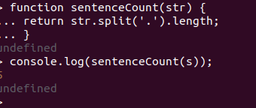

2. total words count
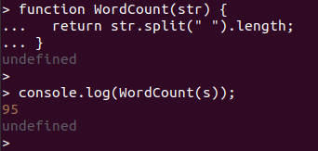

3.Total characters Count
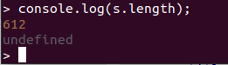

4.total occurrences count of the word "paragraph"

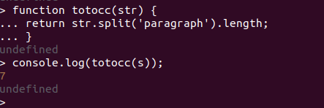
5.Total count of the special characters used in the paragraph

> function countSpecial (str){
... const punct = "!,\;\.-?";
... let count = 0;
... for(let i = 0; i < str.length; i++){
..... if(!punct.includes(str[i])){
....... continue;
....... }
..... count++;
..... }
... return count;
... }
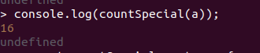

6.Replace the word "paragraph" with "para"

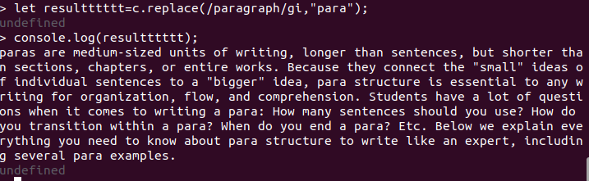
.

7.Slice the paragraph from the second sentence.
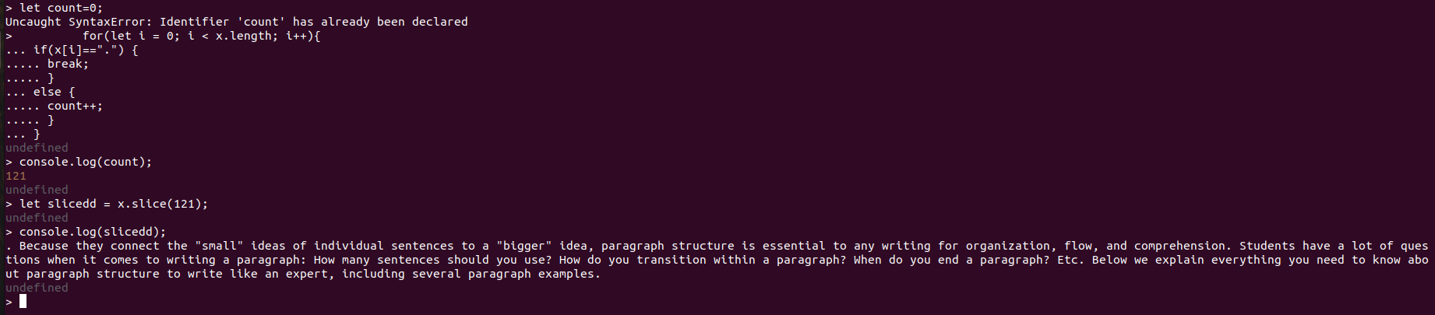
> let count=0;
> for(let i = 0; i < x.length; i++){
... if(x[i]==".") {
..... break;
..... }
... else {
..... count++;
..... }
... }
undefined
> console.log(count);
121
undefined
> let slicedd = x.slice(121);
undefined
> console.log(slicedd);
. Because they connect the "small" ideas of individual sentences to a "bigger" idea, paragraph structure is essential to any writing for organization, flow, and comprehension. Students have a lot of questions when it comes to writing a paragraph: How many sentences should you use? How do you transition within a paragraph? When do you end a paragraph? Etc. Below we explain everything you need to know about paragraph structure to write like an expert, including several paragraph examples.
undefined

